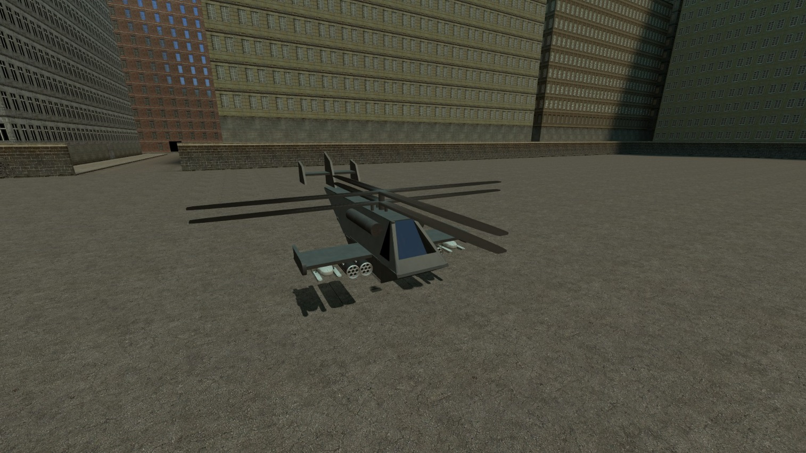**Dark Eagle AT**

**Description:**

Fast and agile helicopter armed with 4 Hellfires and 4 ZUNI pods. Hellfire locks to the nearest vehicle (including chairs) to the helicopter with player driving it. Based on 1st helicopter I’ve built

**Controls:**

1. Hold Alt (Default walkbutton) – camera will change to 1st person
2. Center the camera
3. Hold Alt again to 3rd person
4. Press F (Flashlight) to startup

Mouse – General control. Look left to turn helicopter left, look down to nose down etc

W/S – Ascend/Descend

A/D – Strafe left/right

LMB/RMB – launch hellfire from left/right rack

Shift – shoot unguided rockets

R – Reload

**MV 88 AT**

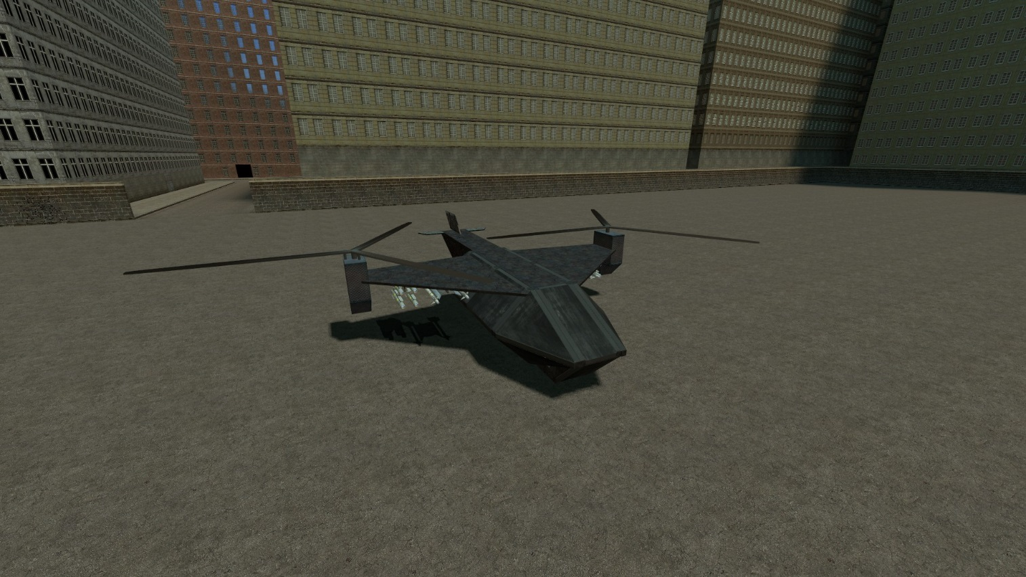

**Description:**

Heavy version of Dark Eagle AT. Armed with 8 Hellfires and 4 AA missiles

**Controls:**

1. Hold Alt (Default walkbutton) – camera will change to 1st person
2. Center the camera
3. Hold Alt again to 3rd person
4. Press F (Flashlight) to startup

Mouse – General control. Look left to turn helicopter left, look down to nose down etc

W/S – Ascend/Descend

A/D – Strafe left/right

LMB/RMB – launch hellfire from left/right rack

Shift – shoot 2 AA missiles

R – Reload